


Experiment 9
Branch: MCA (AI ML) Kargil | Semester: 2
Student Name: Priyanka Chandwani | UID: 25MCI10122
Subject Name: Technical Training - I Lab | Subject Code: 25CAP-652
Section/Group: 25MAM_KAR-1 | Date of Performance: 07-04-2026

Experiment Aim:
To implement database triggers in PostgreSQL to automatically calculate values and enforce constraints during data insertion operations.
Tools used: PostgreSQL Objectives:

• Trigger Implementation: To understand how to create and use triggers in PostgreSQL.
• Automation: To automate calculation of total payable amount using triggers.
• Data Integrity: To enforce constraints using trigger conditions.
• Real-time Processing: To execute logic automatically before inserting data.
Theory:

1



Triggers are special database objects that automatically execute a function when a specified event (INSERT, UPDATE, DELETE) occurs on a table. In PostgreSQL, triggers are associated with trigger functions written in PL/pgSQL. They help maintain data integrity, enforce business rules, and automate tasks.

Experiment Steps:

Step 1: Creating Table Query:
CREATE TABLE employee ( emp_id INT PRIMARY KEY, emp_name VARCHAR(50), working_hours INT, perhour_salary NUMERIC, total_payable_amount NUMERIC );

Step 2: Creating Trigger Function Query:
CREATE OR REPLACE FUNCTION CACULATE_PAYABLE_AMOUNT() RETURNS TRIGGER
AS
$$ BEGIN
NEW.total_payable_amount := NEW.perhour_salary * NEW.working_hours;
IF NEW.total_payable_amount > 25000 THEN

2



RAISE EXCEPTION 'INVALID ENTRY BEACUSE PAYABLE AMOUNT CAN NOT BE GREATER THAN 25000';
END IF;

RETURN NEW; END;
$$ LANGUAGE PLPGSQL;

Step 3: Creating Trigger
Query:
CREATE OR REPLACE TRIGGER AUTOMATED_PAYABLE_AMOUNT_CALCULATION
BEFORE INSERT ON employee
FOR EACH ROW
EXECUTE FUNCTION CACULATE_PAYABLE_AMOUNT();

Step 4: Inserting Valid Data
Query:
INSERT INTO EMPLOYEE(emp_id, emp_name, working_hours, perhour_salary) VALUES (1, 'AKASH', 10, 1000);

3



Output:

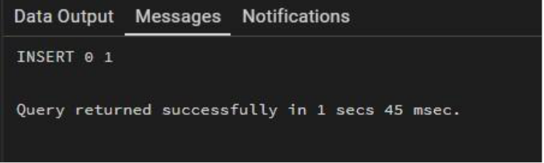

Step 5: Inserting Invalid Data (Exception Case)
Query:
INSERT INTO employee(emp_id, emp_name, working_hours, perhour_salary) VALUES (2, 'Ankush', 8, 100000);
Output:
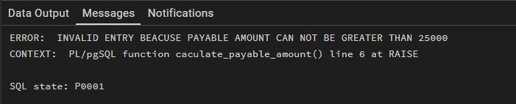

Step 6: Retrieving Data
Query:
SELECT * FROM EMPLOYEE;

Output:

4



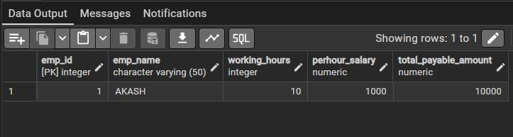

Outcomes:
• I will be able to create and use triggers in PostgreSQL.
• I will understand how to automate calculations using triggers.
• I will enforce constraints using trigger conditions.
• I will understand real-time execution of database logic.

5

